Dear Valued Customer,

We have been notified of a recall for the MediHoney Wound & Burn Dressing Paste that you purchased from Performance Health. This voluntary correction has been initiated due to the potential for pinholes in the applicator pouch film (see Figures 1a and 1b- red circle) which creates a sterility concern. The paste is not impacted by this potential sterility concern. There is no risk to the end user if the applicator is not used to apply the paste directly on the wound.

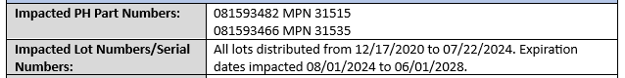

Here are next steps for you to report if you are impacted:
- Visit our website at https://www.performancehealth.com/product-recall
- Please do not use the tip of the product.

Please respond to this letter by emailing us at: SMB-PH-US03-Regulatory@performancehealth.com

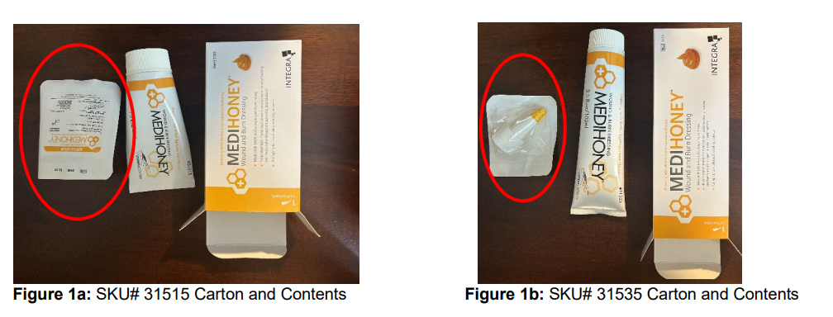

Best Regards,
Performance Health

